**Scripting using WebDriver**

Let us understand how to work with WebDriver. For demonstration, we would use http://www.calculator.net/. We will perform a "Percent Calculator" which is located under "Math Calculator". We have already downloaded the required WebDriver JAR's. Refer the chapter "Environmental Setup" for details.

**Step 1**: Launch "Eclipse" from the Extracted Eclipse folder.

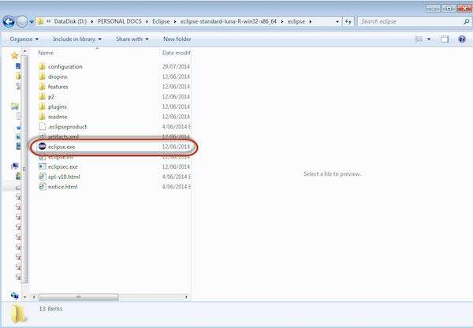

**Step 2**: Select the Workspace by clicking the 'Browse' button.

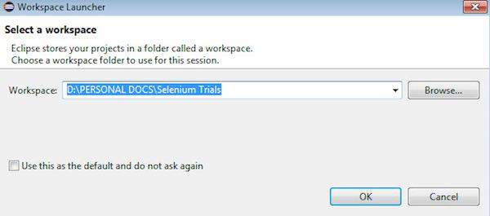

**Step 3**: Now create a 'New Project' from 'File' menu.

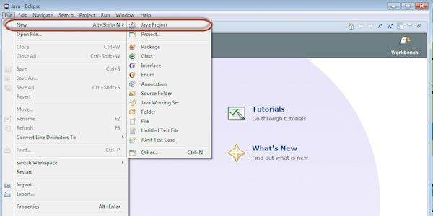

**Step 4**: Enter the Project Name and Click 'Next'.

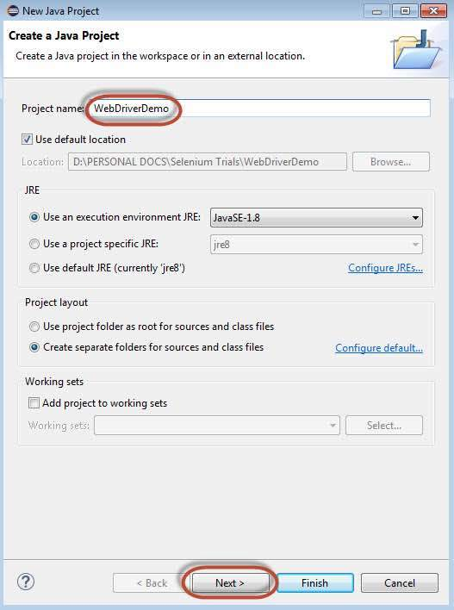

**Step 5**: Go to Libraries Tab and select all the JAR's that we have downloaded. Add reference to all the JAR's of Selenium WebDriver Library folder and also selenium-java-2.42.2.jar and selenium-java-2.42.2-srcs.jar.

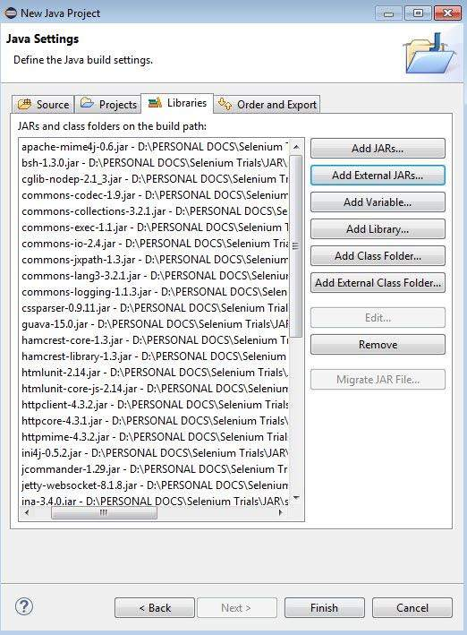

**Step 6**: The Package is created as shown below.

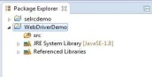

**Step 7**: Now right-click on the package and select 'New' >> 'Class' to create a 'class'.

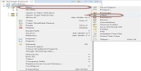

**Step 8**: Now name the class and make it the main function.

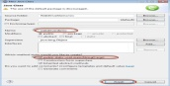

**Step 9**: The class outline is shown as below.

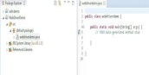

**Step 10**: Now it is time to code. The following script is easier to understand, as it has comments embedded in it to explain the steps clearly. Please take a look at the chapter "Locators" to understand how to capture object properties.

import java.util.concurrent.TimeUnit;

import org.openqa.selenium.*;

import org.openqa.selenium.firefox.FirefoxDriver;

public class webdriverdemo {

public static void main(String[] args) {

WebDriver driver = new FirefoxDriver();

//Puts an Implicit wait, Will wait for 10 seconds before throwing exception

driver.manage().timeouts().implicitlyWait(10, TimeUnit.SECONDS);

//Launch website

driver.navigate().to("http://www.calculator.net/");

//Maximize the browser

driver.manage().window().maximize();

// Click on Math Calculators

driver.findElement(By.xpath(".//*[@id='menu']/div[3]/a")).click();

// Click on Percent Calculators

driver.findElement(By.xpath(".//*[@id='menu']/div[4]/div[3]/a")).click();

// Enter value 10 in the first number of the percent Calculator

driver.findElement(By.id("cpar1")).sendKeys("10");

// Enter value 50 in the second number of the percent Calculator

driver.findElement(By.id("cpar2")).sendKeys("50");

// Click Calculate Button

driver.findElement(By.xpath(".//*[@id='content']/table/tbody/tr/td[2]/input")).click();

// Get the Result Text based on its xpath

String result = driver.findElement(By.xpath(".//*[@id='content']/p[2]/span/font/b")).getText();

// Print a Log In message to the screen

System.out.println(" The Result is " + result);

//Close the Browser.

driver.close();

}

}

**Step 11** : The output of the above script would be printed in Console.

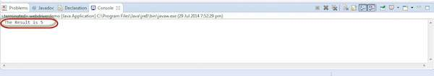

**Most Used Commands**

The following table lists some of the most frequently used commands in WebDriver along with their syntax.

|  |  |
| --- | --- |
| **Command** | **Description** |
| driver. get("URL") | To navigate to an application. |
| element.sendKeys("inputtext") | Enter some text into an input box. |
| element.clear() | Clear the contents from the input box. |
| select.deselectAll() | Deselect all OPTIONs from the first SELECT on the page. |
| select.selectByVisibleText("some text") | Select the OPTION with the input specified by the user. |
| driver.switchTo().window("windowName") | Move the focus from one window to another. |
| driver.switchTo().frame("frameName") | Swing from frame to frame. |
| driver.switchTo().alert() | Helps in handling alerts. |
| driver.navigate().to("URL") | Navigate to the URL. |
| driver.navigate().forward() | To navigate forward. |
| driver.navigate().back() | To navigate back. |
| driver.close() | Closes the current browser associated with the driver. |
| driver.quit() | Quits the driver and closes all the associated window of that driver. |
| driver.refresh() | Refreshes the current page. |